**Paul Webber**

Director

Paul has worked on numerous major structural and civil projects in Australia and Asia. With 39 years’ experience Paul has acquired specialist skills in the design, planning and design management on a variety of projects including high-rise residential and commercial structures, resort facilities, retail centres, industrial facilities, aircraft hangars, health and infrastructure projects.

**Recent Relevant Project Experience Includes**

LandmarkTower 500 Pacific Highway St Leonards NSW

5-7 Charles Street Parramatta NSW, Mixed use

UEM Conservatory, 9-23 Mackenzie St Melbourne VIC

MY80 410 Elizabeth Street Melbourne VIC

Empire 398 Elizabeth Street Melbourne VIC

297-300 King Street Melbourne VIC

Marina Tower, Pearl River Lots A & B Docklands VIC

Arcare Aged Care Sorrento VIC

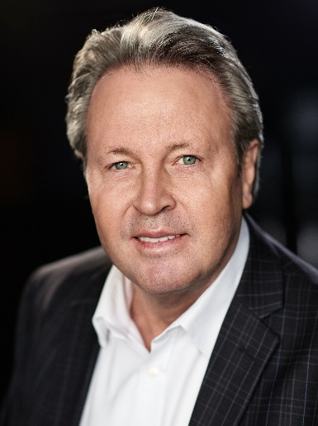

**Peksoon Kwan**

Director

Pek-Soon has worked with Paul Webber since 2003. He is responsible for managing all aspect of project delivery. His hands-on approach from conceptual design and feasibility studies to managing the design documentations and construction phase is well received by both design consultants and construction personnel in the industry.

**Recent Relevant Project Experience Includes**

Shadowplay 308 City Road Melbourne VIC

Empire 398 Elizabeth Street Melbourne VIC

UEM Conservatory McKenzie Street Melbourne VIC

MY80 410 Elizabeth Street Melbourne VIC

Elm & Stone, New Quay Lot 9A and 9B Docklands

Pearl River Docklands Melbourne VIC

601 St Kilda Road Melbourne VIC

The Park House, 627 Victoria Street Abbotsford VIC

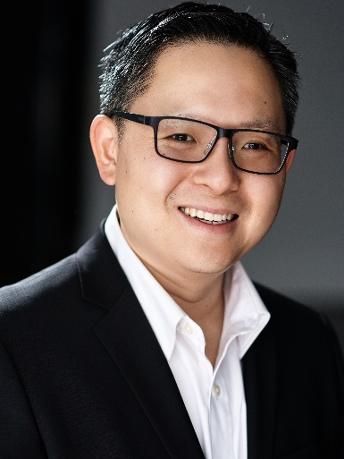

**Andrew Woo**

Principal

Andrew has over 15 years of structural and civil engineering design experience in a range of commercial, industrial & residential projects. Professional responsibilities include total packages of design, drafting and documentation incorporating cost effective delivery of design to requirements and demanding deadlines.

**Recent Relevant Project Experience Includes**

Toga High St, Penrith NSW

Defence House Australia, Arkadia, Alexandra, NSW

511 Botany Road, Zetland, NSW

Australian Unity Project Albert, South Melbourne VIC

540 Flinders St, Melbourne VIC

297 King St, Melbourne VIC

18 Moray St, South Melbourne VIC

133 Rosslyn St, South Melbourne VIC

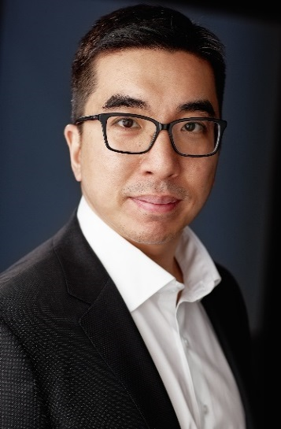

**Paul Malady**

Director

Paul has worked on a variety of project types and scale throughout Australia and the Middle East over the past 20 years. During this time Paul has gained experience in all aspects of engineering from conceptual design through detailed design and construction phases. Paul has successfully delivered a variety projects including retail, commercial, residential and industrial from concept to completion.

**Recent Relevant Project Experience Includes**

Queen Victoria Market (QVM), Munro Site, Melbourne

Aspire, 299 King Street Melbourne, Residential

480 Elizabeth Street Melbourne, Residential

627 Chapel Street South Yarra, Commercial

The Normanby 199 Normanby Road, Southbank

Vic and Vine 1-57 Wellington Street, Collingwood

VU, Victoria University City Tower, Melbourne

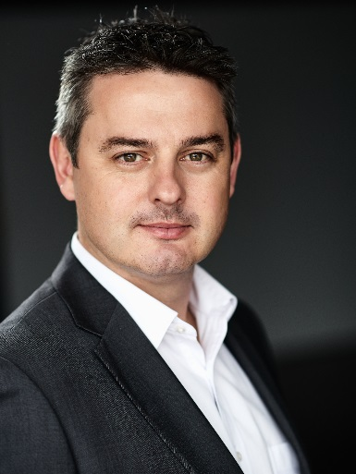

**Rohan Games**

Principal

Rohan has over a decade of engineering design experience in a range of commercial, industrial and residential projects. Professional responsibilities include total packages of design, drafting and documentation.

**Recent Relevant Project Experience Includes**

LandmarkTower 500 Pacific Hwy St Leonards NSW

1496 Pacific Hwy Warrawee NSW

23-25 Church Avenue Mascot NSW

Dee Why RSL NSW

Coward Street Mascot NSW

570 Bourke Street Melbourne VIC

710 Station Street Box Hill VIC

24-28 Stanley Street Collingwood VIC

7-8 Bowen Crescent, Melbourne

33 Coventry Street, Southbank

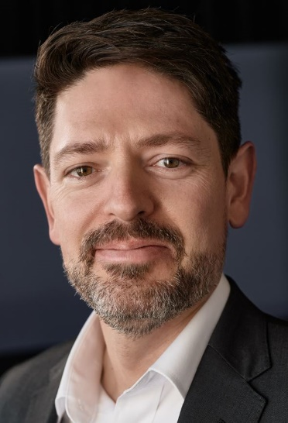

**Vinh Hua**

Technical Director

Vinh has over 18 years of structural and civil engineering design experience and has developed specialist skills in Finite Element Analysis and the design of lateral load resistance systems for various high rise projects both locally and overseas. As an Associate Engineer, Vinh is responsible for total packages of design, drafting and documentation.

**Recent Relevant Project Experience Includes**

Union Tower 296 Lt Lonsdale Street Melbourne

Yarra House 18 Yarra Street South Yarra

Coles Canterbury

MY80 Apartments 410 Elizabeth Street Melbourne

Empire 398 Elizabeth Street Melbourne

Marina Tower Docklands

Yarra One 16-22 Claremont Street South Yarra

Marriott Hotel Docklands

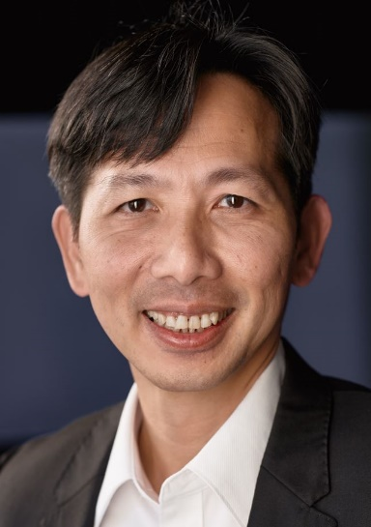

**Angelo Thurairajah**

Technical Director

Angelo is responsible for concept through to detailed engineering design. Angelo has more than 30 years of structural engineering design experience in a range of high-rise, commercial, industrial and residential projects. Angelo specialises in the design of lateral stability elements of numerous high-rise buildings such as 12 Hassall Street Parramatta, Budds Beach Gold Coast, 6&8 Parramatta Square, Greenland Tower Sydney, Aspire Tower Melbourne, 183 A’Beckett Street Melbourne, Aurora Tower Melbourne, Swanston Central Melbourne, The Ribbon Sydney, VCCC Melbourne, Soul Tower Gold Coast, Torch Tower Dubai, Villamar Towers Bahrain, QNB Tower Qatar and Pearl Tower Bahrain.

**Recent Relevant Project Experience Includes**

12 Hassall Street Parramatta/4, 6 & 8 Parramatta Square

VU Tower Melbourne, Aspire Tower Melbourne

Greenland Tower Sydney, 550 Pacific Hwy St Leonards

141 King St Melbourne, 183 A’Beckett St Melbourne

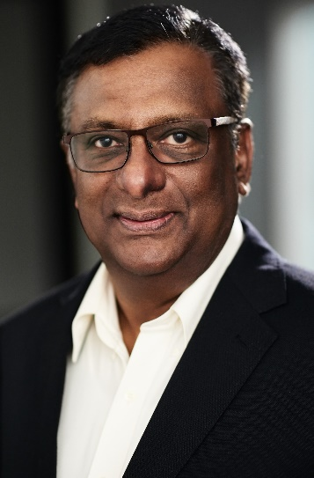

**Paul Watters**

Principal

Paul has over a decade of engineering design experience in a range of commercial, industrial and residential projects. Professional responsibilities include total packages of design, drafting and documentation.

**Recent Relevant Project Experience Includes**

Jam Factory Redevelopment, South Yarra

St Moritz, St Kilda

Northcote Plaza Redevelopment, Northcote

Pentridge Mixed Use Development Coburg

570 Bourke Street Commercial Melbourne

A’Beckett Street, Student Accom. Melbourne

Elm & Stone Apartments Docklands

UoM Royal Parade Student Accommodation Parkville

UoM Lincoln Square Student Accommodation Carlton

PEGS School Keilor East



**Brad Cameron**

Senior Associate - Lead Draftsman

Brad has over 14 years of structural drafting design experience in a range of commercial and residential projects which include steel, reinforced/post tensioned concrete, masonry and timber. As well as modelling and drafting Brad’s other responsibilities include to maintain the current drafting and modelling system, perform QA drafting checks and to mentor other members of the drafting and modelling team to ensure Webber Design’s drawings are neat and to Australian Standards.

**Recent Relevant Project Experience Includes**

The Landmark 500 Pacific Highway St Leonards NSW

649 Victoria Street Abbotsford

16-22 Claremont Street South Yarra

Eve Apartments, Eve 3 and Eve 4, Erskineville NSW

FV 1 & 2, Barry Parade QLD

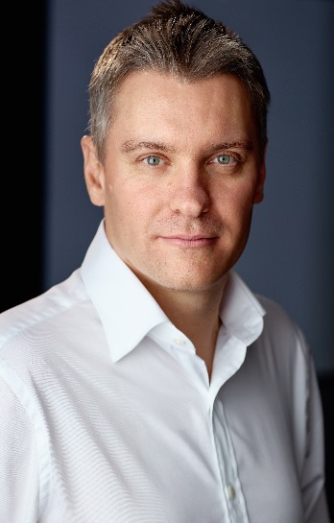

**James Kiel**

Perth Manager/Team Leader

James is an enthusiastic Senior Structural Engineer who works closely with clients and project teams to deliver effective design solutions. While working within the ever growing constraints of today’s market, James maintains a meticulous attention to detail and a strong work ethic to meet project deadlines. James has provided quality design solutions for all manner of projects from high rise residential and commercial to the more intricate educational or luxury developments.

**Recent Relevant Project Experience Includes**

Tanami Gold Mine Mixed Use Precinct NT

553-561 Wellington Street Perth Peer Review WA

52 Adelaide Street Fremantle Peer Review WA

Curtin University Exchange Structural Certification WA

661 Chapel Street South Yarra VIC

Flagstaff Green 15-31 Batman St West Melbourne VIC

18-24 Moray Street Southbank VIC

Gem Apartments, Waterline Place Williamstown VIC

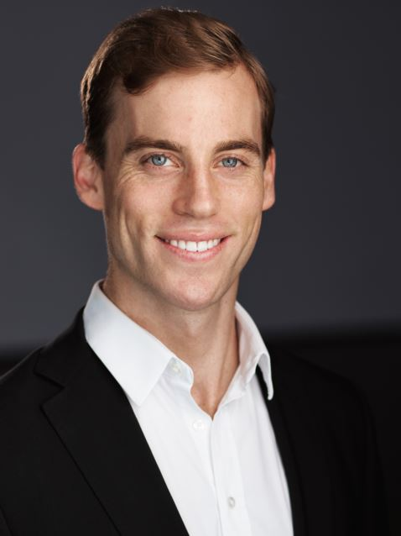

**Vinod Shinde**

Associate Structural Design Engineer

Vinod joined the Webber Design team in 2017, his specific role includes analytical engineering design and coordinating the design between consultants and builders to achieve the best outcome. Vinod has gained vast experience through various portfolios and has a passion for structural design and development. His professionalism and enthusiasm make him a highly valued member of our team.

**Recent Relevant Project Experience Includes**

5 Davidson Street South Yarra

600 Church Street Richmond

Parkhouse 627 Victoria Street Abbotsford

627 Chapel Street South Yarra

22-26 Gordon Street Cremorne

The Moorings Martha Cove

IGLU 8 Claremont Street South Yarra

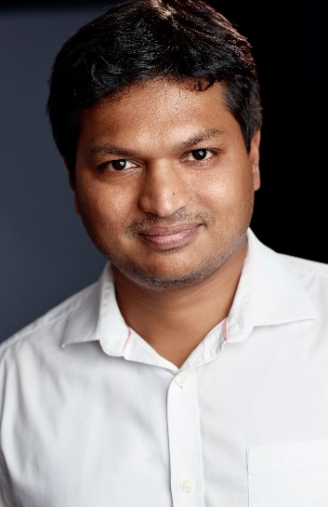

**Toan Pham**

Associate Structural Design Engineer

Toan has over 20 years national and international experience in the design of commercial, hospital and residential buildings. Toan has worked in large design offices in Australia and Asia and taken part in many iconic projects in the field of high rise structures with thorough knowledge of the integration of building services, building facades and special architectural requirements.

**Recent Relevant Project Experience Includes**

Market Square, Adelaide

QVM - Queen Victoria Market, Melbourne

253 Normanby Rd, South Melbourne

Calvary Bethlehem 476 Kooyong Rd Caulfield South

Harvest Square, Brunswick East

Bunnings Doncaster Road, Doncaster

Vincent Care Victoria, Flemington

The Village, Cheltenham

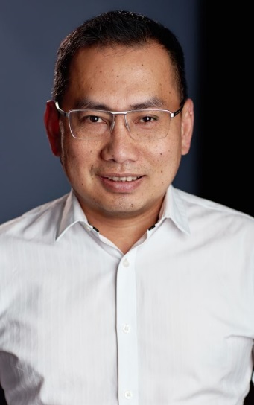

**Chris Moritis**

Structural Design Engineer

Chris is responsible for the detailed design of all types of concrete, steel and timber structures. Chris has experience in commercial, residential and major government infrastructure projects across all phases of development, including schematic, detailed design, and construction phases. Chris is committed and enthusiastic to continue to further his professional development to carry out designs utilising all the latest engineering methods and technologies available to ensure a high quality outcome for every project.

**Recent Relevant Project Experience Includes**

34 Cubitt St, Cremorne (Office)

1-7 Eastbourne St, Windsor (Office)

Fitzroy Plaza, Fitzroy (Office)

Coles Supermarket, Woodend (Retail)

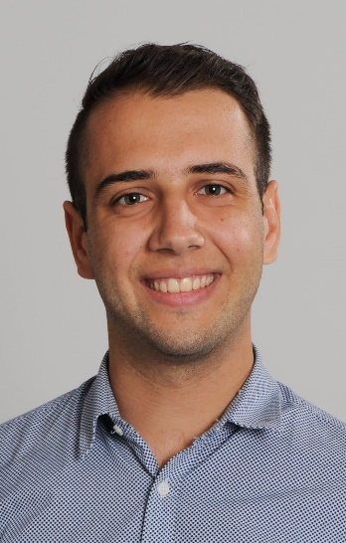

**Jeff Chia**

Structural Design Engineer

With the experience in both construction and consulting, Jeff emphasize a lot on design practicability, construction sequencing and cost effectiveness. Jeff has a wide range of structural design experience, projects starting from residential housing to multi-storey apartment buildings. He never stops learning the latest technology within the industry and determined to continuously developed in structural engineering to provide high quality and cost effective designs.

**Recent Relevant Project Experience Includes**

Canvas, 270-272 Barkly Street, Brunswick

One Wellington, 8-12 Punt Rd, St Kilda

Cultivate, 294 Bell St, Heidelberg West

Raleigh Street, Windsor

368 Smith Street, Collingwood

RSH Social Housing, 147 Elizabeth St, Richmond

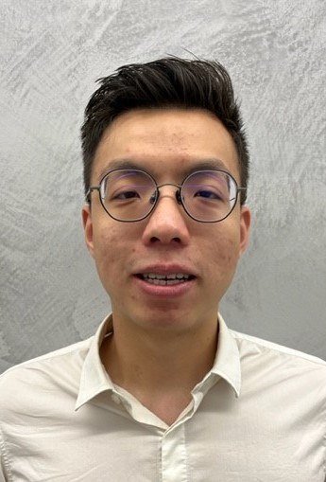

**James Vassiliou**

Senior Structural Design Engineer

James has built an extensive design portfolio of varying size and complexity within the residential, educational, and commercial market spaces. James has a strong passion for analytical engineering design, which has nurtured his ability to develop innovative and cost-effective design solutions for clients. James understands the value in professional relationships, leveraging them to achieve excellent outcomes for the projects that he is involved in.

**Recent Relevant Project Experience Includes**

1 Champ St, Coburg - Adina Hotel

162 Williams Rd, Hawksburn - Hawksburn

1-2 Plowman Place, Frankston – Horizon

601 St Kilda Rd, St Kilda – St Boulevard

600 Doncaster Rd, Doncaster – The Point

Keilor Rd Keilor East – PEGS Gymnasium

277-279 Centre Rd Bentleigh – Mixed Use Development

25-29 Coventry St, Southbank – Botanic

**Recent Relevant Project Experience Includes**

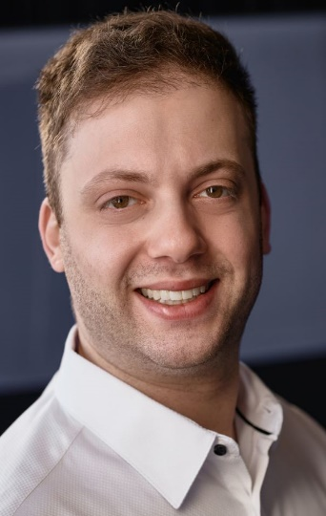

**Richard Reddin**

Associate Structural Design Engineer

With a career spanning over 8 years including local and international engineering experience, Richard has built an extensive portfolio of complex architecturally designed residential, commercial and retail projects. Richard enjoys working closely with project teams in a proactive and collaborative manner, with a focus on delivering commercially viable pragmatic engineering designs that preserve the architect intent where possible

**Recent Relevant Project Experience Includes**

Parkview Apartments 680 Heidelberg Road Alphington

Eve Apartments Erskineville NSW

Victoria & Vine Apartments Collingwood

107 Wellington Street Collingwood, Residential

Arcare Aged Care 800 Melbourne Road Sorrento

Yarrabend Alphington, Boiler House, Residential

141 La Trobe Street Melbourne

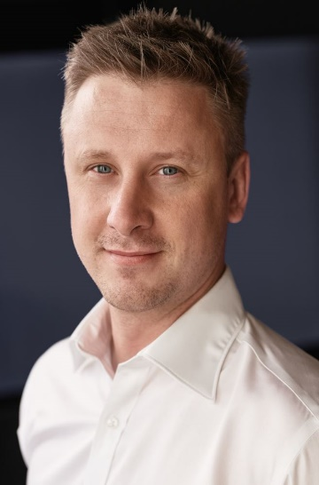

**Matthew Gartland**

Senior Structural Design Engineer

Matt has developed broad experience in the construction industry working in both Australia and the UK. Matt has extensive experience in the design and delivery of a wide variety of new build and refurbishment projects and possesses excellent management and technical skills. Matt coordinates with clients and other project members through from initial design stage through to construction on site.

**Recent Relevant Project Experience Includes**

West End Development Rosslyn Street, Residential

199-201 Normanby Rd Southbank, Mixed Use

316-322 Johnson St Abbotsford, Residential

Kooyong Tennis Club Extension, Mixed Use

Kensington Row Phase 2 London, Residential

Broken Wharf House London, Commercial

The Old Vinyl Factory London, Mixed Use

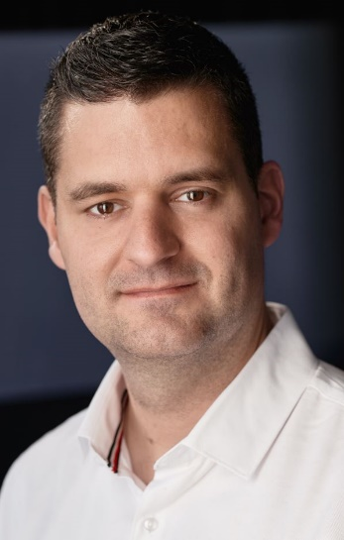

**Gracio Permata**

Senior Civil Engineer

Gracio is responsible for civil engineering work for Melbourne and Sydney projects which include a broad range of tasks from residential to commercial projects. Gracio has over 7 years of industry experience in structure and civil engineering. His responsibilities include design and draft (2D and 3D) of stormwater drainage system, footpath and road pavements, analyse stormwater quality (water sensitive urban design), liaising with council and project stakeholders through design and constructions and manage civil team and projects.

**Recent Relevant Project Experience Includes**

Bunnings Hotel Doncaster VIC

Queen Victoria Munro Site Melbourne VIC

Victoria University City Tower Melbourne VIC

159-161 Epping Road Macquarie Park NSW

Monte Sant Angelo Mercy College NSW

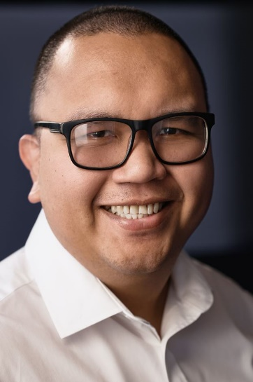

**Mohamed Tarek Khalil**

Structural Site Engineer

Tarek has a 15 years of Engineering career in local and international major infra-structure, residential, commercial and military projects. Tarek enjoys working closely with project teams as a proactive team member quality control on site and smooth communication to maintain quality and progress in the projects. Graduated in Egypt, member of Engineers Australia since 2015. Worked in major projects in Qatar and Australia.

**Recent Relevant Project Experience Includes**

Queen Victoria Market Stage 1 Hub

183-189 A’Beckett Street Melbourne, Student Acc

92 Beach Street Port Melbourne, Residential

134-160 Spencer Street Melbourne, Residential

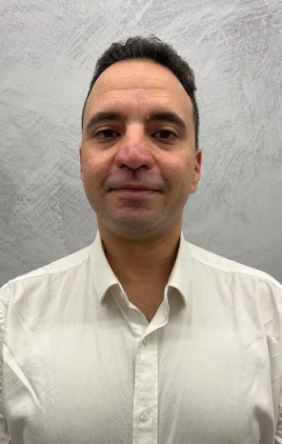

**Jason Loi**

Structural Design Engineer

Jason has over 10 years of experience in both temporary and permanent works engineering. His experience expands through projects in residential, commercial and public venues. His role includes proactively coordinating with clients and conduction detailed design analysis to efficiently provide solutions throughout the projects. Jason has a double degree in Engineering and Finance, and achieved his charter ship status in 2019.

**Recent Relevant Project Experience Includes**

1000 La Trobe Street Melbourne, Commercial

114-130 Albert Park Road Melbourne, Residential

81 Bridge Street Port Melbourne, Residential

44 Oxford Street Collingwood, Residential

48 Gipps Street Collingwood, Commercial

71 Langridge Street Collingwood, Commercial



**Guy Al-Bayati**

Structural Design Engineer

Guy has a PHD in structural engineering with more than 5-year local experience and 6-year overseas experience. He specializes in design for post tensioning/reinforced slabs and FRP rectification for many projects in Australia. Guy has a passion for efficient yet practical design that is easy to construct.

**Recent Relevant Project Experience Includes**

164 Roden Street West Melb, Residential

Brighton Boulevard, Luxury Home NSW

79-83 Hawthorn Rd Caulfield, Residential

398-400 Johnston Street Abbotsford, Residential

459-481 Church Street Richmond (Basement, Ground and 3 buildings)

10x Storey Melbourne Airport

50x Storey with 3x Basements Residential Towers at Victoria Square Stage 1

Gladstone Street South Melbourne, Residential

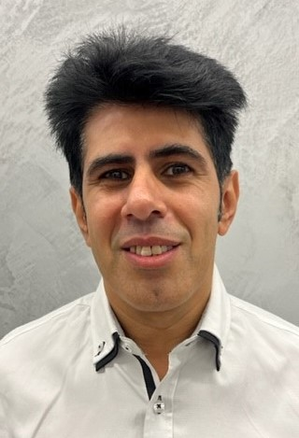

**Erwan Ong**

Structural Design Engineer

**Recent Relevant Project Experience Includes**

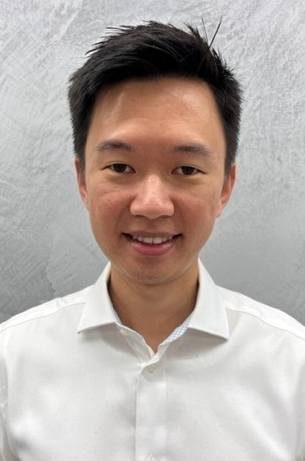

**Manoj Bhupathi**

Structural Design Engineer

**Recent Relevant Project Experience Includes**

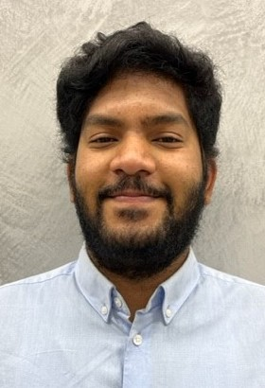

**Oliver Morris**

Structural Design Engineer

Since joining the Webber Design team in 2020, Oliver has applied his knowledge of conceptual design, detailed design and stakeholder liaison across a range of high-rise, aged-care and residential projects. With his passion for structural engineering established at a young age, Oliver’s respect for the structural design process results in every design submitted adhering to a high standard that all stakeholders, and himself personally, can take pride in.

**Recent Relevant Project Experience Includes**

627 Chapel Street South Yarra, High-rise residential

Japara Brighton, Aged-care

Aspire, King Street Melbourne, High-rise residential

Casey Green, Narre Warren, Residential

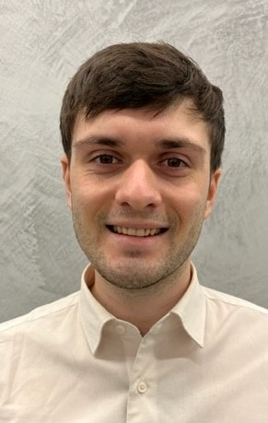

**Marcelo Matamala**

Structural Design Engineer

**Recent Relevant Project Experience Includes**

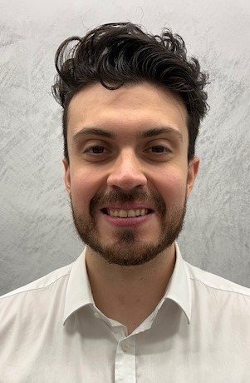

**Joseph Aiezza**

Structural Design Engineer

**Recent Relevant Project Experience Includes**

**Zeyad**

Structural Design Engineer

**Recent Relevant Project Experience Includes**

**Ha Nguyen**

Graduate Structural Design Engineer

**Recent Relevant Project Experience Includes**